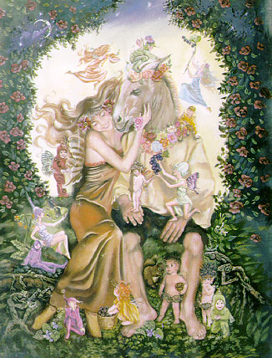
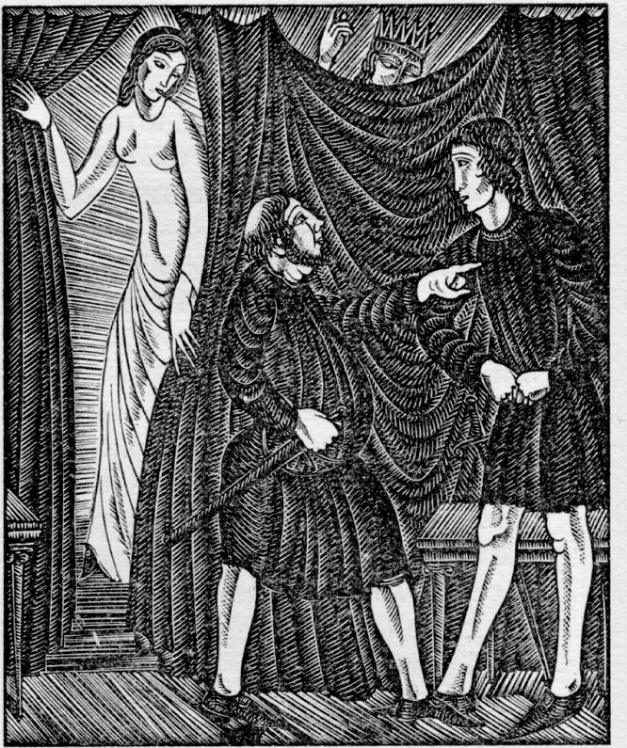
Hamlet
Julius Caesar

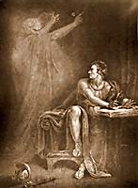
A Midsummer Night's dream

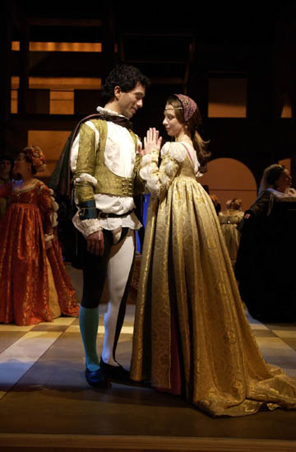
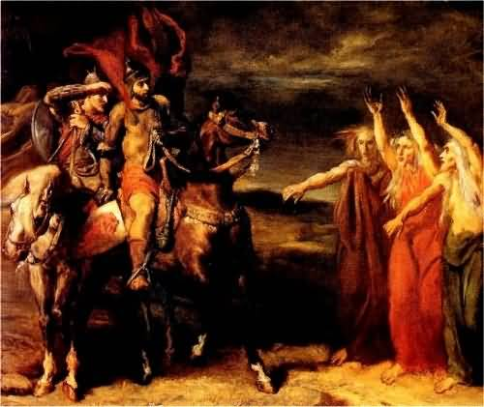

Shakespeare’s Plays in modern times & Sonnets

Developed By: Nicole Schiavoni

Overview

Language Arts/Literature/English Class
For Grades 9th-12th

Over the course of the year we have read numerous plays by William Shakespeare. In this cyber inquiry you will all be split up into groups of five. Within your group you will be looking at one of the plays. The plays will be assigned to each group by picking a number from a hat. Each group will be presenting the class with a power point on some background information about the play; this should only take up 2-3 slides on your power point. Then each group will be looking at the main characters in the play and deciding what they would be like in modern times. For example, if Romeo and Juliet were alive today, how would they be different? What would they do in life? How would they act? What would they say differently?
We have also learned about how Shakespeare wrote his sonnets using iambic pentameter. So each member of the group will be writing their own sonnet based on what a modern look on their play would be. Everyone will have his or her own sonnet!
The groups will be presenting a power point presentation on what they think the characters would be like in modern times. Also each group member will be reading his or her sonnet to the class. This project is a culmination of everything we have learned this year, but remember it’s supposed to be fun, so enjoy it! Feel free to act out your sonnets or dress up for the part.
Students will have class time designated for looking through the books we have in class. We will also have designated days where we will be going to the library for research. There will be books in the classroom as well as books on hold in the library. You should use your Shakespeare plays. There will also be movie versions available to help inspire you.

Introduction

The Plays we will be doing are as follows:

A Midsummer Night’s Dream
Romeo and Juliet
Hamlet
Macbeth
Julius Caesar

William Shakespeare wrote many plays over the course of his lifetime. Shakespeare was a poet, playwright, and actor who grew up in a little town called Stratford-upon-Avon. He was born in April 1564 and died in April 1616. He is often called England's national poet and the "Bard of Avon". His surviving works consist of 38 plays, 154 sonnets, two long narrative poems, and several other poems. His plays have been translated into every major living language and are performed more often than those of any other playwright.
A Midsummer Night’s Dream tells of love between fairies and mortals. There are many characters such as Thesesus, the Duke of Athens, Hippolyta, Queen of the Amazons. Demetrius, who loves Hermia, who loves Lysander. And Helena who loves Demetrius. Also there are Oberon, the fairy King, Titania, the fairy queen, and Puck, the king’s merry servant. Also there is a group of villagers who wish to perform a play at the wedding of Thesesus and Hippolyta. The main village craftsman is Bottom who Queen Titania falls in love with for an interlude. It takes you through their night in the forest and all the wonders that happen to them. At the end of the play the only one that remains is Puck who asks that the audience remember it as if it were a dream.
Shakespeare’s longest play, Hamlet is a classic revenge tragedy. The play opens with two guards on watch at the castle. The ghost of Hamlet's father appears to the men but disappears without saying a word. The next night Hamlet joins the men and speaks to his father's ghost. The ghost reveals to him that he was murdered by his own brother Claudius. The ghost also asks Hamlet to swear to avenge his death. Claudius is now the king and is married to his mother. His apparent madness worries the king who orders that Hamlet leave Denmark and be sent to England. Hamlet returns, and with a mix of poison and swords, everyone ultimately dies. The theme of the story is revenge, however Shakespeare questions whether or not it is significant if one dies achieving it.
Romeo and Juliet is arguably Shakespeare’s most famous play. The prologue establishes that the play will be a tragedy, and that the children of two feuding families, the Montagues and the Capulets, will fall in love and ultimately die. Romeo and Juliet fall in love at first sight, initially unaware of each other’s status. When it is revealed that they are supposed to be bitter enemies, Juliet decides to fake her own death in order to be with her one true love. Upon Romeo’s arrival, Juliet has yet to wake and Romeo too thinks she is dead. Deciding he’d rather join her than be without her, Romeo drinks poison thus killing himself. Juliet wakes to find him dead, then takes his dagger and kills herself as well. Although reconciliation is acquired, it is at great sacrifice. Through mix-ups and misunderstandings, the story is a tale about chance, young love, and impulse.
Macbeth is a dark and ominous story. It is suggestive of a world turned topsy-turvy by foul an unnatural crimes. The major conflicts occurring are the struggle within Macbeth between his ambition and his sense of right and wrong; the struggle between the murderous evil represented by Macbeth and Lady Macbeth and the best interests of the nation, represented by Malcolm and Macduff. The bloody battle in Act I foreshadows the bloody murders later on; when Macbeth thinks he hears a voice while killing Duncan, it foreshadows the insomnia that plagues Macbeth and his wife.
Julius Caesar is a tragedy. It portrays the conspiracy against the Roman dictator Julius Caesar, his assassination and its aftermath. It is one of several Roman plays that he wrote, based on true events from Roman history.

Investigation
The websites and books listed below are to help you begin your research for the project. Most of them have background information about the plays and some have ideas for a modern day Shakespeare. When you use background information from a source remember to use MLA citation, so you do not plagiarize. Anyone who does plagiarize will fail the assignment and face severe consequences. You may use other websites and books, however, be sure to evaluate them for their accuracy. If you are unsure about the accuracy of a source, feel free to ask me and I will help you to decide. You will have access to books and movies in the classroom portfolio, but please try to keep everything organized. Also if you are taking something homes do not forget to sign it out with me first.

Websites:
http://www.shakespeare-online.com/

http://shakespeare.mit.edu/

http://shakespeare.palomar.edu/

http://www.online-literature.com/shakespeare/

http://www.online-literature.com/shakespeare/macbeth/

http://www.rhymezone.com/shakespeare/

http://www.poetrydoctor.org/sonnet.htm

http://shakespeare.palomar.edu/works.htm

http://www.shakespeareswords.com/

Books:
Shakespeare: The Invention of the Human
by Harold Bloom

The Genius of Shakespeare
by Jonathan Bate

Shakespeare’s Sonnets: The Folger Shakespeare Library
Edited by: Barbara A Mowat and Paul Werstine

Movies:
I do not mind you watching the movies, however, be aware that there are only a few movies and many of you so if possible try to watch them as a group and bring them back the following day.

Hamlet starring Ethan Hawke (2000)

Hamlet starring Kenneth Branagh (1996)

Hamlet starring Mel Gibson (1990)

Romeo and Juliet (1954)

Romeo and Juliet (1992)

Romeo + Juliet (1996)

Julius Caesar (1950), starring Charlton Heston as Antony and Harold Tasker as Caesar.
Julius Caesar (1953), starring Marlon Brando as Antony and Louis Calhern as Caesar.
Julius Caesar (1970), starring Charlton Heston as Antony and John Gielgud as Caesar.
A midsummer Nights dream starring Michelle Pfeiffer (1999)

Macbeth starring Nicol Williamson (1983)

Gathering & Sorting

When you are collecting information be sure to go back over your notes from class. If you feel you are missing something then go to our class website and download a copy of any notes and power points we may have used in class. Make sure you look at multiple sources, do not just rely on one source for all of your information. Things to look for include:
- Background on where your play was first performed
- Any fun facts you can find out about the play and Shakespeare
- Specific traits that the characters have
- Modern events that may relate to what happened in your play
- The character you feel you want to “modernize”
- What would Shakespeare have been like in today’s world

The Portfolio

Make sure you take advantage of the portfolio and use it’s resources to your full advantage. If you find a really good resource along your searches that is not in the portfolio please add it so your classmates may also take advantage of it. For example if you find a good website then print out the homepage and put it under your story’s “website” section of the portfolio. If you find a book that helps you then write down it’s information on a 3X5 card and place it into the “book list” section of the portfolio. Be sure to include your groups name and period on whatever source you might add so that I know whom to thank.
There are several books and movies in the portfolio to benefit you on this project. Always remember to sign out what you use and not to keep it for to long, as other groups may need to use it as well.

Sharing

All of you will be working on these projects during class. We will spend this week doing research and next week working on sonnets. The groups will be presenting on Thursday and Friday of next week, however, all groups power points and sonnets must be submitted to me at the beginning of the period on Thursday.
Today is Monday and we will be going through the portfolio and discussing possible ideas. I will hand out your group assignments and we will pick out of a hat to see what group will get each play. You will have some time at the end of the period to meet with your group and plan what you want to look at.
The next 3 days we will be spending in the library doing research. Then on Friday you will have the period to discuss with your groups and plan.

Evaluation

Your grade will be based on a 25-point scale. You will have the opportunity to earn a maximum of 5 points in 5 categories, which are as follows:

Teamwork (group grade (5) and personal grade (5)):

You will each be giving all your team members a grade from 1-5 that will help make this grade so please be honest. You will each get an individual grade for teamwork and a group grade for overall teamwork. Also if one member is not pulling their weight you need to tell me
(5 points) The team worked together well. Everyone did his or her own part. You will each be giving all your team members a grade from 1-5 that will help make this grade so please be honest. Also if one member is not pulling their weight you need to tell me before the project is over so I can intervene.
(3-4 points) Team worked together most of the time. Almost everyone did his or her part.
(2 points) Students had many disputes and problems getting the work done, but still did some of the work.
(0-1 point) Students did not function together at all. Lots of fighting occurred and nothing was done.

Individual Sonnets:
(5 points) Sonnet is original and well thought out. Sonnet follows iambic pentameter and is free of all spelling mistakes.
(3-4 points) Sonnet is well thought out, but there are some spelling or grammar mistakes. Or sonnet does not follow iambic pentameter correctly.
(1-2 points) Sonnet does not make sense and is full of mistakes.
(0 points) Sonnet is not handed in at all.

Power Point:
(5 points) Power point is original with picture images and colors. Power point has transitions and is animated. Follows the guidelines as lade out for you.
(3-4 points) Power Point is good, but does not have animation or imagery. It has many errors in grammar and spelling.
(1-2 points) Power Point has very little research put into it. It is very short and unorganized. It has so many errors it does not make sense.

Presentation:
(5 points) Everyone in the group spoke. Speakers were knowledgeable about the subject and did not read directly from slides. Presentation was original and done with feeling.
(3-4 points) Most of the group presented. Speakers read from slides occasionally.
(1-2 points) The presentation was unorganized and obviously not practiced. Speakers did not look up from reading slides or sonnet.

* Possibility of extra credit points if you dress up or act out your sonnets when read. *

